Learning Objectives for the week:
Reading:
The children will be able to retell the story of ‘The Little Red Hen’.

Phonics:
The children will recognise the letters ee,igh,oa , and read words with these sounds.
The children will be able to read their word set.
The children will be able to recognise the tricky word they.
The children will be able to spell the tricky words: the, to, I, no, go, was, he, she, we, me and be.

Writing:
The children with support will be able to write a simple sentence for a picture.
The children will be able to write their first name and surname in cursive letters.(Please encourage your child to write their name daily)

Maths:
The children will be able to subtract a number from 10.
The children will be able to write a subtraction number sentence.
 | Registration  9:10-9:20  Microsoft Teams all children to attend registration | 9:20-9:40 | 9:40-10:30 | Brain Break https://www.bbc.co.uk/teach/supermovers/ks1-collection/zbr4scw | 11:00--12:00 | Lunchtime 12:00-1:20 | 1:20-2:00  Review of learning  Class Teacher to call groups of children on Microsoft Teams. | 2:00-2:45  Review of learning  Class Teacher to call groups of children on Microsoft Teams. | 2:45-3:00
Monday | Microsoft Teams  Morning Welcome  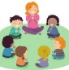 | Phonics  Link: https://www.youtube.com/watch?v=6xM941AjNtg&list=PLuGr6z2H2KNHwnu179dNafu7_mj4Nvjgp&index=7  Lesson: 9 (ee) | Reading  Phonics Play  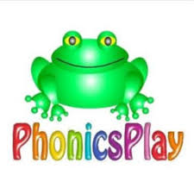  Link: https://www.phonicsplay.co.uk/resources/phase/2/picnic-on-pluto  Picnic on Pluto (Phase 3 ee)  Can you read the sentence and draw a picture:  The dog is in the bath.  The man is in the rain.  I can sing. |  | Reading  Bug club : Read Books and word sets  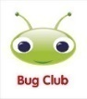 |  | Understanding The World  Oak Academy  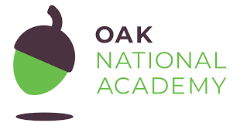  Link: https://classroom.thenational.academy/lessons/to-know-the-names-for-the-offspring-animals-not-human-6mr36r  Lesson: On the Farm. Growing (Animals)  To know the names for the offspring animals  Microsoft Teams  Reading Review of Learning- Word sets (Individually)  1:20- 2:00 Yellow group  2:00- 2:40 Green group | CHILD INITIATED LEARNING  The children can choose their own toy/learning activity | Story Time  Pick your favourite story or read your school books
Tuesday | Microsoft Teams  Morning Welcome  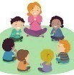 | Phonics  Link: https://www.youtube.com/watch?v=QFVxjSke60Q&list=PLuGr6z2H2KNHwnu179dNafu7_mj4Nvjgp&index=5  Lesson: 11 (igh) | Literacy  Oak Academy  https://classroom.thenational.academy/lessons/to-listen-and-join-in-with-a-story-c5h36t  Lesson: Little Red Hen  Lesson 1:  To listen and join in with a story. |  | Writing  Can you write a simple sentence for the picture?  e.g.  It is wet in the rain.  Can you write your tricky words?  the, to, I, no, go, was, he, she, we, me, be. |  | D and T  Can you make a bird feeder ready for The Big Bird Watch on Thursday?  Here are some examples:  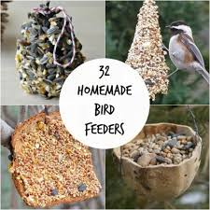  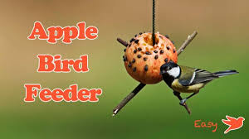 | CHILD INITIATED LEARNING  The children can choose their own toy/learning activity  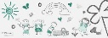  Microsoft Teams  Writing Review of Learning  2-2:15 Yellow group  2:15-2:30 Green group | Story Time  Pick your favourite story or read your school books
Wednesday | Microsoft Teams  Morning Welcome  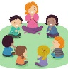 | Phonics: Recap the ‘igh’ digraph and play a game to practise your reading.  Phonics Play  Link: https://www.phonicsplay.co.uk/resources/phase/2/picnic-on-pluto  Picnic on Pluto (Phase 3 igh) | Maths  Oak Academy  Link: https://classroom.thenational.academy/lessons/understanding-the-concept-of-subtraction-as-take-away-part-1-cmu32r  Lesson: Addition and subtraction within 10  Lesson 3:  Understanding the concept of subtraction as take away (Part 1) |  | Maths  Mathletics activity  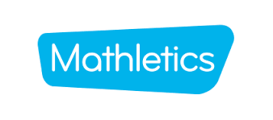 |  | PSHE  Oak Academy  Link:  https://classroom.thenational.academy/lessons/lockdown-heroes-c4rk2c  Lesson: A new Normal: lesson 5  Lockdown Heroes | CHILD INITIATED LEARNING  The children can choose their own toy/learning activity  Microsoft Teams  Maths Review of Learning  2-2:15 Yellow group  2:15-2:30 Green group | Story Time  Pick your favourite story or read your school books
Thursday | Microsoft Teams  Morning Welcome  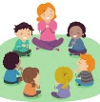 | Phonics  Link:  https://www.youtube.com/watch?v=xV3aj4F6v0I&list=PLuGr6z2H2KNHwnu179dNafu7_mj4Nvjgp&index=4  Lesson: 12 (oa) | Literacy  Oak Academy  Link:  https://classroom.thenational.academy/lessons/to-sing-and-map-a-story-6wukgd  Lesson: Little Red Hen:  Lesson 2:  To sing and map a story. |  | Reading  Phonics Game (2do) |  | Understanding the World  Can you observe out of your window or in the garden the birds that you see?  Can you draw a picture of the birds you see and label them?  Which birds did you see the most of?  Which birds did you see the least of?  Did you spot a robin? | CHILD INITIATED LEARNING  The children can choose their own toy/learning activity | Story Time  Pick your favourite story or read your school books
Friday | Microsoft Teams  Morning Welcome  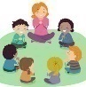 | Phonics: Recap the ‘oa’ digraph and play a game to practise your reading.  Phonics Play  Link: https://www.phonicsplay.co.uk/resources/phase/2/picnic-on-pluto  Picnic on Pluto (Phase 3 oa) | Maths  Oak Academy  Link:  https://classroom.thenational.academy/lessons/understanding-the-concept-of-subtraction-as-take-away-part-2-6nk3et  Lesson: Addition and subtraction within 10  Lesson 4:  Understanding the concept of subtraction as take away (Part 2) |  | Maths  Mathletics activity |  | Music  Oak Academy  Link: https://classroom.thenational.academy/lessons/me-and-my-family-part-2-6hk36t  All about Me  Lesson 4: Me and my family (Part 2) | GOLDEN TIME  Activity of choice | Story Time  Pick your favourite story or read your school books

