Learning Objectives for the week: (Please check purple mash emails to find out which colour group your child is in ready for Microsoft Teams)

Reading:
The children will be able to retell the story of ‘The Little Red Hen’.
To be able to name the characters in the story and talk about why they didn’t help The Little Red Hen.

Phonics:
The children will recognise the letters oo,oo and read words with these sounds.
The children will be able to read their word set.
The children will be able to recognise the tricky word are.
The children will be able to spell the tricky words: the, to, I, no, go, was, he, she, we, me, be and all.

Writing:
The children with support will be able to write labels for animals in the story.
The children will be able to write simple sentence for a picture.
The children will be able to write their first name and surname in cursive letters.(Please encourage your child to write their name daily)

Maths:
The children will be able to add and subtract using a number track.
The children will be able to say doubles to 5.
 | Registration  9:10-9:20  Microsoft Teams all children to attend registration | 9:20-9:40 | 9:40-10:30 | Brain Break https://www.bbc.co.uk/teach/supermovers/ks1-collection/zbr4scw | 11:00--12:00 | Lunchtime 12:00-1:20 | 1:20-2:00  Review of learning  Class Teacher to call groups of children on Microsoft Teams. | 2:00-2:45  Review of learning  Class Teacher to call groups of children on Microsoft Teams. | 2:45-3:00
Monday | Microsoft Teams  Morning Welcome | Phonics  Link: https://www.youtube.com/watch?v=PA8GodBBGKk&list=PLuGr6z2H2KNHwnu179dNafu7_mj4Nvjgp&index=3  Lesson: 13 (oo for book) | Reading  Phonics Play  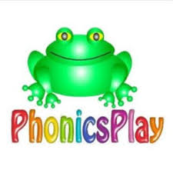  Link: https://www.phonicsplay.co.uk/resources/phase/2/dragons-den  Dragons Den (Phase 3 oo) |  | Reading  Bug club : Read Books and word sets |  | Understanding The World  Oak Academy  Link: https://classroom.thenational.academy/lessons/to-know-what-farm-animal-offspring-need-to-grow-68v62c  Lesson: On the Farm. Growing (Animals)  To know what farm animal offspring need to grow  Microsoft Teams  Reading Review of Learning- Word sets (Individually)  Please see your purple mash emails for your weekly time.  1:00- 1:55 Blue group  2:00- 2:50 Red group | CHILD INITIATED LEARNING  The children can choose their own toy/learning activity | Story Time  Pick your favourite story or read your school books
Tuesday | Microsoft Teams  Morning Welcome | Phonics  Link: https://www.youtube.com/watch?v=CowkysLju7k&list=PLuGr6z2H2KNHwnu179dNafu7_mj4Nvjgp&index=2  Lesson: 14 (oo for moon) | Literacy  Oak Academy  https://classroom.thenational.academy/lessons/to-focus-on-character-cnk3jr  Lesson: Little Red Hen  Lesson 3:  To focus on character. |  | Writing  Can you write a simple sentence for the picture?  e.g.  I can see an owl at night.  Can you write your tricky words?  the, to, I, no, go, was, he, she, we, me, be, all. |  | Computing  Please share the story:  https://www.childnet.com/ufiles/Detective-Digiduck---150.pdf  Can you answer the questions below?  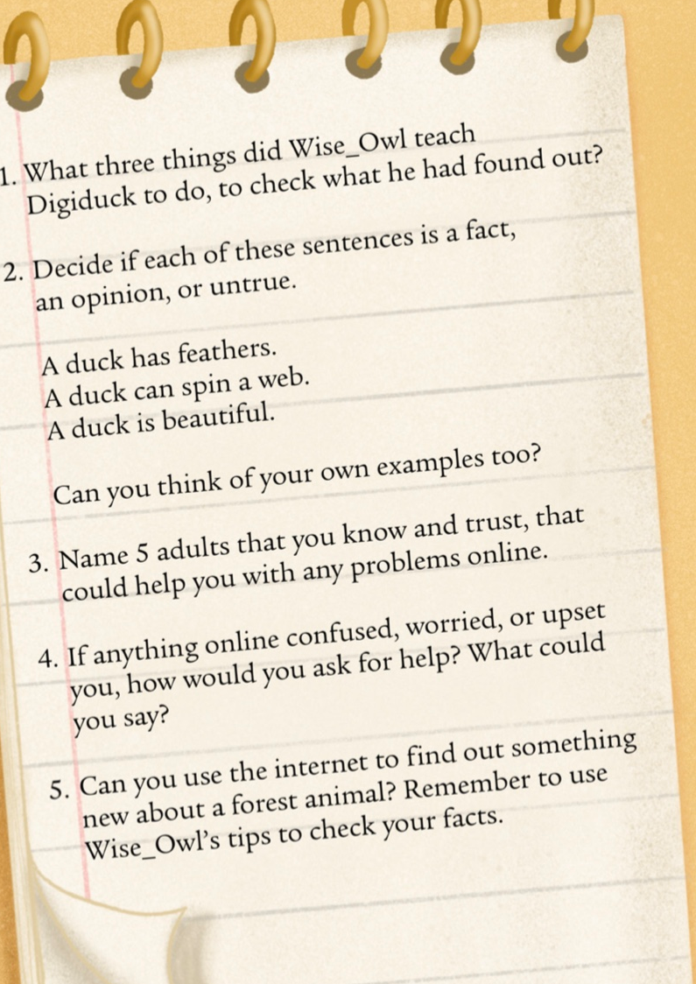  Short video about safer internet day:  https://www.youtube.com/watch?v=oWwb9z2Qw6s | CHILD INITIATED LEARNING  The children can choose their own toy/learning activity  Microsoft Teams  Literacy Review of Learning  2-2:15 Red group  2:15-2:30 Blue group | Story Time  Pick your favourite story or read your school books
Wednesday | Microsoft Teams  Morning Welcome | Phonics: Recap the ‘oo’ digraph and play a game to practise your reading.  Phonics Play  Link: https://www.ictgames.com/phonicsPop/index.html  Picnic on Pluto (Phase 3 oo) | Maths  Oak Academy  Link: https://classroom.thenational.academy/lessons/adding-and-subtracting-using-a-number-track-crv6at  Lesson: Addition and subtraction within 10  Lesson 5:  Adding and subtracting using a number track |  | Maths  Mathletics activity |  | PSHE  Oak Academy  Link:  https://classroom.thenational.academy/lessons/super-juice-crtk6d  Lesson: A new Normal: lesson 6  Super juice | CHILD INITIATED LEARNING  The children can choose their own toy/learning activity  Microsoft Teams  Maths Review of Learning  2-2:15 Red group  2:15-2:30 Blue group | Story Time  Pick your favourite story or read your school books
Thursday | Microsoft Teams  Morning Welcome | Phonics  Link:  https://www.youtube.com/watch?v=Am9SGxnpJ7U&list=PLuGr6z2H2KNHwnu179dNafu7_mj4Nvjgp&index=1  Lesson: 15 Review of sounds | Literacy  Oak Academy  Link:  https://classroom.thenational.academy/lessons/to-reenact-a-story-focusing-on-character-6gu32t  Lesson: Little Red Hen:  Lesson 4:  To reenact a story focusing on character. |  | Reading  Phonics Game (2do) |  | Music  Oak Academy  Link: https://classroom.thenational.academy/lessons/me-and-my-friends-part-1-cdjp6t  All about Me  Lesson 5: Me and my friends (Part 1) | CHILD INITIATED LEARNING  The children can choose their own toy/learning activity | Story Time  Pick your favourite story or read your school books
Friday- Can you wear something red to help celebrate Chinese New Year! | Microsoft Teams  Morning Welcome | Phonics: Recap the digraph we have learned so far and play a game to practise your reading.  Phonics Play  Link: https://www.phonicsplay.co.uk/resources/phase/2/pick-a-picture  Pick a picture (Phase 3 digraphs) | Maths  Oak Academy  Link:  https://classroom.thenational.academy/lessons/understanding-the-concept-of-double-6gw3ad  Lesson: Doubling and halving.  Lesson 1:  Understanding the concept of double. |  | Maths  Mathletics activity |  | Understanding the World  Video’s about Chinese New Year  https://www.youtube.com/watch?v=c8ssHXZ9_qU  https://www.youtube.com/watch?app=desktop&v=1cRMRp9-Z08  Chinese New Year Animal Story:  https://www.topmarks.co.uk/ChineseNewYear/ZodiacStory.aspx  Activity:  This year is the year of the Ox.  Can you make your own Ox? | GOLDEN TIME  Activity of choice | Story Time  Pick your favourite story or read your school books

