Learning Objectives for the week: (Please note that there will be no afternoon review sessions this week)
Reading:
The children will be able to retell their own story using their story plan.
Phonics:
The children will recognise the letters ur, ow, oi and read words with these sounds.
The children will be able to read their word set.
The children will be able to recognise the tricky word her.
The children will be able to spell the tricky words: the, to, I, no, go, was, he, she, we, me, be, all, you and are.
Writing:
The children will be able to write simple sentence for a picture.
The children will be able to write their first name and surname in cursive letters.(Please encourage your child to write their name daily)
Maths:
The children will be able to find half of a number.
The children will be able to recall doubles.
 | Registration  9:10-9:20  Microsoft Teams all children to attend registration | 9:20-9:40 | 9:40-10:30 | Brain Break https://www.bbc.co.uk/teach/supermovers/ks1-collection/zbr4scw | 11:00--12:00 | Lunchtime 12:00-1:20 | 1:20-2:00 | 2:00-2:45 | 2:45-3:00
Monday | Microsoft Teams  Morning Welcome  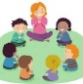 | Phonics  Link: https://www.youtube.com/watch?v=9VYUdc1WKEE  Lesson: 21 (ur) | Reading  Phonics Play  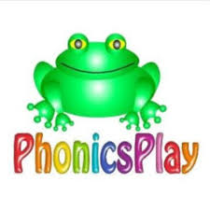  Link: https://www.phonicsplay.co.uk/resources/phase/3/sentence-substitution-ph3  Sentence Substitution  Can you read the sentence and draw a picture:  The man is in the red car.  I can hear a horn. |  | Reading  Bug club : Read Books and word sets  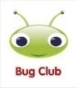 |  | Understanding The World  Oak Academy  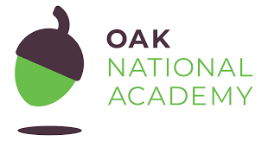  Link: https://classroom.thenational.academy/lessons/to-identify-foods-that-are-healthy-and-foods-that-are-not-healthy-64wk0d  Lesson: Healthy Eating  To identify foods that are healthy and foods that are not healthy | CHILD INITIATED LEARNING  The children can choose their own toy/learning activity | Story Time  Pick your favourite story or read your school books
Tuesday | Microsoft Teams  Morning Welcome  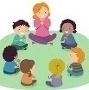 | Phonics  Link: https://www.youtube.com/watch?v=G6u2dmsUYro  Lesson: 22 (ow) | Literacy  Oak Academy  Link: https://classroom.thenational.academy/lessons/to-join-in-with-a-telling-of-a-recycled-story-6xjk6t  Lesson: Little Red Hen  Lesson 7:  To join in with a telling of a recycled story. |  | Writing  Can you write a simple sentence for the picture?  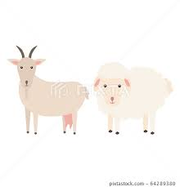  e.g.  A goat and a sheep on the farm.  Can you write your tricky words?  the, to, I, no, go, was, he, she, we, me, be, all, are, you. |  | Computing  Purple Mash  Healthy Eating Plate | CHILD INITIATED LEARNING  The children can choose their own toy/learning activity  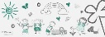 | Story Time  Pick your favourite story or read your school books
Wednesday | Microsoft Teams  Morning Welcome  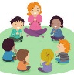 | Phonics: Recap the ‘ow’ digraph and play a game to practise your reading.  Phonics Play  Link: https://www.ictgames.com/phonicsPop/index.html  Phonics Pop (Phase 3 ow) | Maths  Oak Academy  Link: https://classroom.thenational.academy/lessons/understanding-the-concept-of-half-and-double-6ru66r  Lesson: Doubling and halving.  Lesson 4:  Understanding the concept of half and double |  | Maths  Mathletics activity  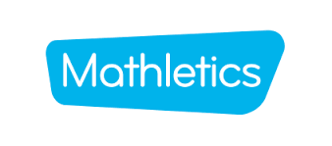 |  | PSHE  Oak Academy  Link:  https://classroom.thenational.academy/lessons/singing-a-song-of-soap-6gt30t  Lesson: Squeaky clean: lesson 2  Singing a song of soap | CHILD INITIATED LEARNING  The children can choose their own toy/learning activity | Story Time  Pick your favourite story or read your school books
Thursday World Book Day  Can you dress as your favourite book character? | Microsoft Teams  Morning Welcome  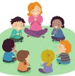 | Phonics  Link:  https://www.youtube.com/watch?v=DEPjV0jzP5k  Lesson: 23 (oi) | Literacy  Oak Academy  Link:  https://classroom.thenational.academy/lessons/to-step-a-recycled-story-and-develop-character-c4t6ad  Lesson: Little Red Hen:  Lesson 8:  To step a recycled story and develop character. |  | Reading  Phonics Game 2do (ur and ow) |  | World Book Day  Please use your login which has been sent through Purple Mash  Link: https://app.discoveryeducation.co.uk/learn/signin  Activity: World Book Day Video  Can you dress up as your favourite story book character?  Can you draw a picture of yourself?  Can you write a sentence to tell me which character you are?  For example: I am Goldilocks. | CHILD INITIATED LEARNING  The children can choose their own toy/learning activity | Story Time  Pick your favourite story or read your school books
Friday- | Microsoft Teams  Morning Welcome  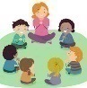 | Phonics: Recap the digraph we have learned so far and play a game to practise your reading.  Please use your login which has been sent through Purple Mash  Link: https://app.discoveryeducation.co.uk/learn/signin  Activity: Sorting sounds (ur,ow) | Maths  Oak Academy  Link:  https://classroom.thenational.academy/lessons/applying-understanding-of-doubling-and-halving-6rwp4r  Lesson: Doubling and halving.  Lesson 5:  Applying understanding of doubling and halving |  | Maths  Mathletics activity |  | Music  Oak Academy  Link:  https://classroom.thenational.academy/lessons/walking-on-my-street-ccu3gr  Journeys and adventures  Lesson 1: Walking on my street | GOLDEN TIME  Activity of choice | Story Time  Pick your favourite story or read your school books

