Microsoft Teams meetings will not take place when your child’s class is open
This timetable is for children who are learning from home and is designed to cover learning between 8th March until 31st March.
Each week, please follow the same structure and learning links below, working systematically through the lessons for each area of learning.

 |  | 9:20-9:40 | 9:40-10:30 | Brain Break https://www.bbc.co.uk/teach/supermovers/ks1-collection/zbr4scw | 11:00--12:00 | Lunchtime 12:00-1:20 | 1:20-2:00 | 2:00-2:45 | 2:45-3:00
Monday |  | Phonics  Link: https://www.youtube.com/playlist?list=PLuGr6z2H2KNGrCOBaVFC23_KL-vzGDSZ_  Lesson: Please work through the Spring Term Reception lessons and complete one each day. | Reading  Phonics Play  Link: http://www.letters-and-sounds.com/phase-3-games.html  Lesson: Please work through the games selecting a new game each time (Phase 3 games and sounds). |  | Reading  Bug club : Read Books and word sets |  | Understanding The World  Oak Academy  Link: https://classroom.thenational.academy/units/spring-cc38  Unit: Spring  Lesson: Please complete a lesson each week. | CHILD INITIATED LEARNING  The children can choose their own toy/learning activity | Story Time  Pick your favourite story or read your school books
Tuesday |  | Phonics  Link: https://www.youtube.com/playlist?list=PLuGr6z2H2KNGrCOBaVFC23_KL-vzGDSZ_  Lesson: Please work through the Spring Term Reception lessons and complete one each day. | Literacy  Oak Academy  https://classroom.thenational.academy/units/the-gingerbread-man-2250  Unit: The Gingerbread Man  Lesson: Please complete one lesson. |  | Writing  Can you write a simple sentence using the digraphs we have been learning? Please see pictures below for examples:  e.g.  Bow down to the king and queen.  The boots are on the mat.  Can you find some pictures to write a sentence about?  Can you write your tricky words?  the, to, I, no, go, was, he, she, we, me, be, all, are. |  | D and T/Art  Can you complete one activity a week. Please see the activities below:  Make your own Gingerbread man  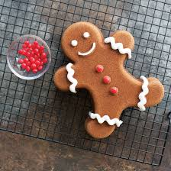  Make a gingerbread man using craft materials?  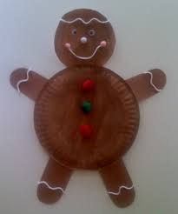  Can you make a spring flower?  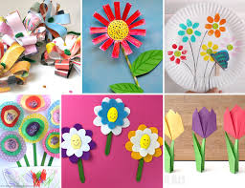  Easter craft  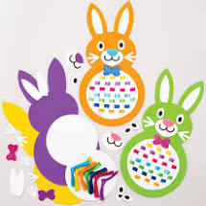 | CHILD INITIATED LEARNING  The children can choose their own toy/learning activity | Story Time  Pick your favourite story or read your school books
Wednesday |  | Phonics Play  Link: http://www.letters-and-sounds.com/phase-3-games.html  Lesson: Please work through the games selecting a new game each time (Phase 3 games and sounds). | Maths  Oak Academy  Link: https://classroom.thenational.academy/units/numbers-within-20-edc2  Unit: Numbers within 20.  Lesson: Please complete one lesson. |  | Maths  Mathletics activity |  | PSHE  Oak Academy  Link:  https://classroom.thenational.academy/units/staying-safe-cd47  Unit: Staying Safe  Lesson: Please complete a lesson each week. | CHILD INITIATED LEARNING  The children can choose their own toy/learning activity | Story Time  Pick your favourite story or read your school books
Thursday |  | Phonics  Link: https://www.youtube.com/playlist?list=PLuGr6z2H2KNGrCOBaVFC23_KL-vzGDSZ_  Lesson: Please work through the Spring Term Reception lessons and complete one each day. | Literacy  Oak Academy  https://classroom.thenational.academy/units/the-gingerbread-man-2250  Unit: The Gingerbread Man  Lesson: Please complete one lesson. |  | Reading  Phonics Game (2do) |  | Computing  Purple Mash  (2do) | CHILD INITIATED LEARNING  The children can choose their own toy/learning activity | Story Time  Pick your favourite story or read your school books
Friday- |  | Phonics: Recap the digraph we have learned so far and play a game to practise your reading.  Please use your login which has been sent through Purple Mash  Link: https://app.discoveryeducation.co.uk/learn/signin | Maths  Oak Academy  Link: https://classroom.thenational.academy/units/numbers-within-20-edc2  Unit: Numbers within 20.  Lesson: Please complete one lesson. |  | Maths  Mathletics activity |  | Music  Oak Academy  Link: https://classroom.thenational.academy/units/out-and-about-bb18  Unit: Out and about  Lesson: Please complete one lesson. | GOLDEN TIME  Activity of choice | Story Time  Pick your favourite story or read your school books

