 | 9:00-9:30 | 9:40-10:30 | Brain Break https://www.bbc.co.uk/teach/supermovers/ks1-collection/zbr4scw | 11:00--12:00 | Lunchtime 12:00-1:20 | 1:20-2:00 | 2:00-2:45 | 2:45-3:00
Monday | Phonics  Link: https://www.youtube.com/watch?v=kLBtb1PFV_g  Lesson: 43 part 1 | Reading  Phonics Play  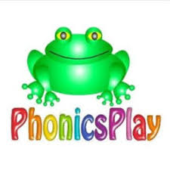  Link: https://www.phonicsplay.co.uk/resources/phase/2/pick-a-picture  Pick a Picture  Phase 3: set 6 and 7 |  | Reading  Bug club : Read Books and words  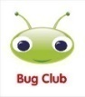 |  | Understanding The World  Oak Academy  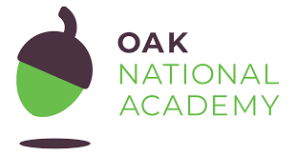  Link: https://classroom.thenational.academy/lessons/to-understand-the-difference-between-hot-and-cold-6cukcr  Lesson: Winter: Hot/Cold  To understand the difference between hot and cold | CHILD INITIATED LEARNING  The children can choose their own toy/learning activity | Story Time  Pick your favourite story or read your school books
Tuesday | Phonics  Link: https://www.youtube.com/watch?v=kI4NZz1JbHE  Lesson: 43 part 2 | Literacy  Oak Academy  https://classroom.thenational.academy/lessons/to-know-that-stories-have-problems-in-them-cnhkgr  Lesson: The Three Billy Goats Gruff: Lesson 1:  To know that stories have problems in them |  | Writing  Can you write a simple sentence for the picture?  e.g.  A tin can. |  | Art  Can you draw/paint a picture of the troll?  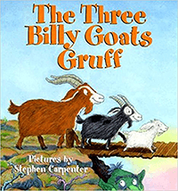 | CHILD INITIATED LEARNING  The children can choose their own toy/learning activity  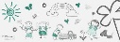 | Story Time  Pick your favourite story or read your school books
Wednesday | Phonics  Link:  https://www.youtube.com/watch?v=DgD6yCIO3pw  Lesson: 44 part 1 | Maths  Oak Academy  Link: https://classroom.thenational.academy/lessons/counting-up-to-15-objects-and-putting-them-in-order-part-1-65hkcc  Lesson: Numbers within 15  Lesson 1:  Counting up to 15 objects and putting them in order (Part 1) |  | Maths  Mathletics activity  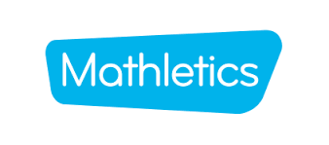 |  | PSHE  Oak Academy  Link: https://classroom.thenational.academy/lessons/healthy-hugs-c5h3ge  Lesson: A new Normal lesson 1  Healthy Hugs | CHILD INITIATED LEARNING  The children can choose their own toy/learning activity | Story Time  Pick your favourite story or read your school books
Thursday | Phonics  Link: https://www.youtube.com/watch?v=eN6GmiiR_2s  Lesson: 44 part 2 | Literacy  Oak Academy  https://classroom.thenational.academy/lessons/to-sing-and-map-the-story-6xgkar  Lesson: The Three Billy Goats Gruff: Lesson 2:  To sing and map the story. |  | Reading  Phonics Game  Link: https://www.phonicsplay.co.uk/resources/phase/2/pick-a-picture |  | Computing  Purple Mash activity | CHILD INITIATED LEARNING  The children can choose their own toy/learning activity | Story Time  Pick your favourite story or read your school books
Friday | Phonics  Link:  https://www.youtube.com/watch?v=JadqW0SsDi4&list=PLuGr6z2H2KNHwnu179dNafu7_mj4Nvjgp&index=8  Lesson: 8 | Maths  Oak Academy  Link: https://classroom.thenational.academy/lessons/counting-up-to-15-objects-and-putting-them-in-order-part-2-cdj38e  Lesson: Numbers within 15  Lesson 2:  Counting up to 15 objects and putting them in order (Part 2) |  | Maths  Mathletics activity |  | Music  Oak Academy  Link: https://classroom.thenational.academy/lessons/this-is-me-60t36d  Lesson: This is me | GOLDEN TIME  Activity of choice | Story Time  Pick your favourite story or read your school books

