Learning Objectives for the week: (Please check purple mash emails to find out which colour group your child is in ready for Microsoft Teams)

Reading:
The children will be able to describe the characters in The Three Billy Goats Gruff.
The children will be able to talk about their favourite part of the story.

Phonics:
The children will recognise the letters x,w,v,j and read words with these sounds.
The children will be able to read their word set.
The children will be able to recognise the tricky words he, she, me, be, we.

Writing:
The children with support will be able to write a simple sentence.
The children will be able to write their first name and surname in cursive letters.(Please encourage your child to write their name daily)

Maths:
The children will be able to count objects carefully to 15 and match to the correct numeral.
 | Registration  9:10-9:20  Microsoft Teams all children to attend registration | 9:20-9:40 | 9:40-10:30 | Brain Break https://www.bbc.co.uk/teach/supermovers/ks1-collection/zbr4scw | 11:00--12:00 | Lunchtime 12:00-1:20 | 1:20-2:00  Review of learning  Class Teacher to call groups of children on Microsoft Teams. | 2:00-2:45  Review of learning  Class Teacher to call groups of children on Microsoft Teams. | 2:45-3:00
Monday | Microsoft Teams  Morning Welcome  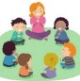 | Phonics  Link: https://www.youtube.com/watch?v=Q0NhvOaLbY4&list=PLuGr6z2H2KNGLy2Tckcy8Kk8u10mXgcmi&index=0  Lesson: 34 part 1 | Reading  Phonics Play  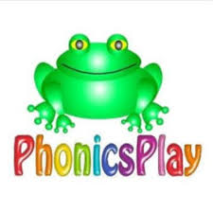  Link: https://www.phonicsplay.co.uk/resources/phase/2/pick-a-picture  Pick a Picture  Phase 3: set 6 and 7 |  | Reading  Bug club : Read Books and words  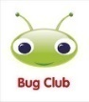 |  | Understanding The World  Oak Academy  Link: https://classroom.thenational.academy/lessons/to-understand-the-difference-between-hot-and-cold-6cukcr  Lesson: Winter: Hot/Cold  To understand the difference between hot and cold  Microsoft Teams  Reading Review of Learning- Word sets (Individually)  Please see your purple mash emails for your weekly time.  1:00- 1:55 Blue group  2:00- 2:50 Red group | CHILD INITIATED LEARNING  The children can choose their own toy/learning activity | Story Time  Pick your favourite story or read your school books
Tuesday | Microsoft Teams  Morning Welcome  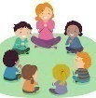 | Phonics  Link: https://www.youtube.com/watch?v=3T6Y5kgSKxY&list=PLuGr6z2H2KNGLy2Tckcy8Kk8u10mXgcmi&index=29  Lesson: 34 part 2 | Literacy  Oak Academy  https://classroom.thenational.academy/lessons/to-know-that-stories-have-problems-in-them-cnhkgr  Lesson: The Three Billy Goats Gruff: Lesson 1:  To know that stories have problems in them |  | Writing  Can you write a simple sentence for the picture?  e.g.  A tin can. |  | Art  Can you draw/paint a picture of the troll?  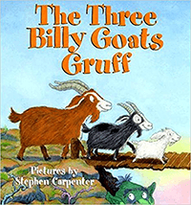 | CHILD INITIATED LEARNING  The children can choose their own toy/learning activity  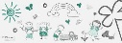  Microsoft Teams  Literacy Review of Learning  2:00-2:15 Red group  2:15-2:30 Blue group | Story Time  Pick your favourite story or read your school books
Wednesday | Microsoft Teams  Morning Welcome  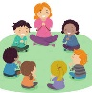 | Phonics  Link: https://www.youtube.com/watch?v=OQ1AnMCGTzg&list=PLuGr6z2H2KNGLy2Tckcy8Kk8u10mXgcmi&index=28  Lesson: 35 part 1 | Maths  Oak Academy  Link: https://classroom.thenational.academy/lessons/counting-up-to-15-objects-and-putting-them-in-order-part-1-65hkcc  Lesson: Numbers within 15  Lesson 1:  Counting up to 15 objects and putting them in order (Part 1) |  | Maths  Mathletics activity  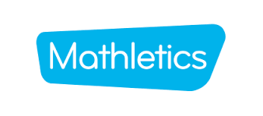 |  | PSHE  Oak Academy  Link: https://classroom.thenational.academy/lessons/healthy-hugs-c5h3ge  Lesson: A new Normal lesson 1  Healthy Hugs | CHILD INITIATED LEARNING  The children can choose their own toy/learning activity  Microsoft Teams  Maths Review of Learning  2:00-2:15 Red group  2:15-2:30 Blue group | Story Time  Pick your favourite story or read your school books
Thursday | Microsoft Teams  Morning Welcome  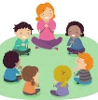 | Phonics  Link: https://www.youtube.com/watch?v=OQ1AnMCGTzg&list=PLuGr6z2H2KNGLy2Tckcy8Kk8u10mXgcmi&index=28  Lesson: 35 part 2 | Literacy  Oak Academy  https://classroom.thenational.academy/lessons/to-sing-and-map-the-story-6xgkar  Lesson: The Three Billy Goats Gruff: Lesson 2:  To sing and map the story. |  | Reading  Phonics Game (2do) |  | Computing  Purple Mash  Fairy Tale Counting (2do) | CHILD INITIATED LEARNING  The children can choose their own toy/learning activity | Story Time  Pick your favourite story or read your school books
Friday | Microsoft Teams  Morning Welcome  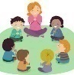 | Phonics  Link: https://www.youtube.com/watch?v=jFR1LoM6Giw&list=PLuGr6z2H2KNGLy2Tckcy8Kk8u10mXgcmi&index=25  Lesson: 36: piece 1 | Maths  Oak Academy  Link: https://classroom.thenational.academy/lessons/counting-up-to-15-objects-and-putting-them-in-order-part-2-cdj38e  Lesson: Numbers within 15  Lesson 2:  Counting up to 15 objects and putting them in order (Part 2) |  | Maths  Mathletics activity |  | Music  Oak Academy  Link: https://classroom.thenational.academy/lessons/this-is-me-60t36d  Lesson: This is me | GOLDEN TIME  Activity of choice | Story Time  Pick your favourite story or read your school books

