Learning Objectives for the week:
Reading:
The children will be able to talk about what happened to Baby Bear in the story (story at group time)
Phonics:
The children will experiment with making different sounds using body percussion.
The children will practise recognising the sounds for s, a,t and p.
Writing:
The children will find objects to make straight lines, zig zags and circles to form letters from their name.
The children will use their name card (that went home at Christmas) to practise copying letters from their name. (Please encourage your child to do this daily)
Maths:
The children will be able to recognise the number 6 and recite numbers 1-6.
10.50-11.00 SNACK TIME
DAY & TIME | 9:00-9:15  REGISTRATION | 9:15-9:30  ADULT LED | 9:30-10:30  CIL | 10.30-10.40  Movement breaks | 10.40-10.50 PHONICS |  | 11:15-11:30  STORY TIME  Join Microsoft Teams
Monday | JOIN MICROSOFT TEAMS FOR OUR MORNING WELCOME  DAYS OF THE WEEK &  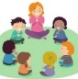  WEATHER SONG. | WRITING  LO: To form recognisable letters from my name.  Use the name card that went home during the Christmas holiday to practise name writing.  What can you find around your house to make the first letter in your name (pipe cleaners to make curvy letters, pasta, lollypop sticks and twigs to make straight lines)  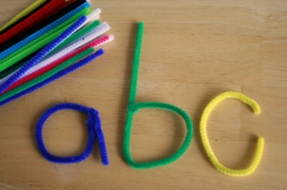 | CHILD INITIATED LEARNING  The children can choose their own toy/learning activity. For example Jigsaws, drawing, painting, reading, role play, purple mash etc.  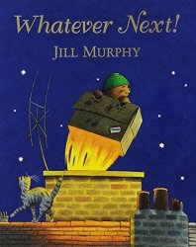  10:15 –JOIN MICROSOFT TEAMS FOR GROUP STORY. | MOVEMENT BREAKS BETWEEN ACITIVITIES  Children copy the actions to the songs using The Learning Station.  Time for a drink and snack  Body Boogie Breaks-  https://www.youtube.com/watch?v=cZeM18fPbvI  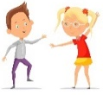 | FAVOURITE STORY  Can they copy any animal noises? Can they describe the setting and character?  Can they join in with repeated phrases? |  | STORY TIME  Story time and Goodbye song.
Tuesday | JOIN MICROSOFT TEAMS FOR OUR MORNING WELCOME  Days of the Week &  Weather song. | UWT- To build a space ship or rocket  Lesson: To understand the different between a space ship and rocket.  LINK- https://classroom.thenational.academy/lessons/build-a-spaceshiprocket-ctjk2e | CHILD INITIATED LEARNING  The children can choose their own toy/learning activity. For example Jigsaws, drawing, painting, reading, role play, purple mash etc. | MOVEMENT BREAKS BETWEEN ACITIVITIES  Children copy the actions to the songs using The Learning Station.  Body Bop-  Time for a drink and snack  https://www.youtube.com/watch?v=QwNBhy3L7vA | NURSERY RHYMES  Nursery rhymes- https://www.bbc.co.uk/teach/school-radio/nursery-rhymes-songs-index/zhwdgwx  Can they sing along with their favourite Nursery rhymes?  Can they sing a favourite Nursery rhyme  Independently?  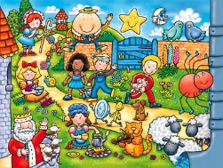  Can they add actions to the Nursery rhymes? |  | STORY TIME  Story time and Goodbye song.
Wednesday | JOIN MICROSOFT TEAMS FOR OUR MORNING WELCOME  Days of the Week &  Weather song. | MATHS - TEN TOWN  Listen to Seal Six’s story and song.  (Use log in details that have been sent over Purple Mash email).  https://www.tentown.co.uk/sign_in.php  Can you find 6 different toys for Seal Six to play with?  Have a go at writing the number 6 using Seal Six’s rhyme.  “Slide down his tail, curl under his nose, nearly there so strike a pose”. | CHILD INITIATED LEARNING  The children can choose their own toy/learning activity. For example Jigsaws, drawing, painting, reading, role play, purple mash etc. | MOVEMENT BREAKS BETWEEN ACITIVITIES  Children copy the actions to the songs using The Learning Station.  Jump up, bend down-  https://www.youtube.com/watch?v=X7jSWdnoshw  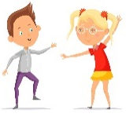 | BODY PERCUSSION  Listen to the song Roly Poly and copy the actions. Can you make up your own actions for the song?  LINK-  https://www.youtube.com/watch?v=R1sdfohQ5AM&feature=youtu.be |  | STORY TIME  Story time and Goodbye song.  Time for a drink and snack
Thursday | JOIN MICROSOFT TEAMS FOR OUR MORNING WELCOME  Days of the Week &  Weather song. | UWT- People Who Help Us:  Lesson: To create Alien handprints  LINK-  https://classroom.thenational.academy/lessons/alien-handprints-61jkec  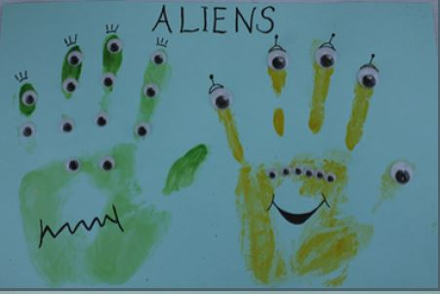 | CHILD INITIATED LEARNING  The children can choose their own toy/learning activity. For example Jigsaws, drawing, painting, reading, role play, purple mash etc. | MOVEMENT BREAKS BETWEEN ACITIVITIES  Children copy the actions to the songs using The Learning Station.  I am the music man-  https://www.youtube.com/watch?v=22kqia2ibVU | BODY PERCUSSION  Practise making a sound pattern using body percussion (clap hands, stamp feet, pat head and repeat).  What other actions can you make using your body? |  | STORY TIME  Story time and Goodbye song.
Friday | JOIN MICROSOFT TEAMS FOR OUR MORNING WELCOME  Days of the Week & Weather song. | PHYSICAL DEVELOPMENT  Warm up-  Listen and join in with:  Funky Monkey-  https://www.youtube.com/watch?v=U9aBYLRhFW8  Bend & Stretch-  https://www.youtube.com/watch?v=S3UwfdiyApI  Do they notice anything different about themselves after warming up? (Feeling hot, red cheeks and heart beating faster).  Andy’s Wild Workouts-  Can you copy Andy’s actions?  Can you make up your own actions for one of the animals?  LINK- https://www.bbc.co.uk/iplayer/episode/p06tmnby/andys-wild-workouts-series-1-5-night-time | CHILD INITIATED LEARNING  The children can choose their own toy/learning activity. For example Jigsaws, drawing, painting, reading, role play, purple mash etc. | MOVEMENT BREAKS BETWEEN ACITIVITIES  Children copy the actions to the songs using The Learning Station.  Boom chicka boom-  https://www.youtube.com/watch?v=69f9sCwhwYk | LETTERS AND SOUNDS  Play “Giggling Graphemes “ on Phonics Play. Can the find the letters s,a,t and p and read their sound?  Here are some phonics resources on Purple Mash to support learning ‘satpin’.  https://www.purplemash.com/#tab/pm-home |  | STORY TIME Story time and Goodbye song.  Time for a drink and snack

