Learning Objectives for the week: (Please check purple mash emails to find out which colour group your child is in ready for Microsoft Teams)

Reading:
The children will be able to retell the story of ‘The Three Billy Goats Gruff’
The children will be able to change a character in the story.

Phonics:
The children will recognise the letters th,ng,ai and read words with these sounds.
The children will be able to read their word set.
The children will be able to recognise the tricky word all.

Writing:
The children with support will be able to write a simple sentence for a picture.
The children will be able to write their first name and surname in cursive letters.(Please encourage your child to write their name daily)

Maths:
The children will be able to add two numbers together to 10.
The children will be able to write an addition number sentence.
 | Registration  9:10-9:20  Microsoft Teams all children to attend registration | 9:20-9:40 | 9:40-10:30 | Brain Break https://www.bbc.co.uk/teach/supermovers/ks1-collection/zbr4scw | 11:00--12:00 | Lunchtime 12:00-1:20 | 1:20-2:00  Review of learning  Class Teacher to call groups of children on Microsoft Teams. | 2:00-2:45  Review of learning  Class Teacher to call groups of children on Microsoft Teams. | 2:45-3:00
Monday | Microsoft Teams  Morning Welcome  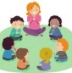 | Phonics  Link: https://www.youtube.com/watch?v=kLBtb1PFV_g  Lesson: 43 part 1 | Reading  Phonics Play  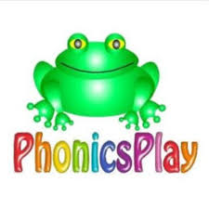  Link: https://www.ictgames.com/mobilePage/tellATRex/index.html  Tell a T-Rex (CVC) |  | Reading  Bug club : Read Books and word sets |  | Understanding The World  Oak Academy  Link: https://classroom.thenational.academy/lessons/to-name-things-that-you-can-see-outside-in-winter-c4t3ec  Lesson: Winter: Hot/Cold  To name things that you can see outside in winter  Microsoft Teams  Reading Review of Learning- Word sets (Individually)  Please see your purple mash emails for your weekly time.  1:00- 1:55 Blue group  2:00- 2:50 Red group | CHILD INITIATED LEARNING  The children can choose their own toy/learning activity | Story Time  Pick your favourite story or read your school books
Tuesday | Microsoft Teams  Morning Welcome  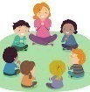 | Phonics  Link: https://www.youtube.com/watch?v=kI4NZz1JbHE  Lesson: 43 part 2 | Literacy  Oak Academy  https://classroom.thenational.academy/lessons/to-tell-the-story-independently-70t3cc  Lesson: The Three Billy Goats Gruff: Lesson 5:  To tell the story independently. |  | Writing  Can you write a simple sentence for the picture?  e.g.  Fish and chips on a dish. |  | D and T  Can you make a bridge for the troll to hide under?  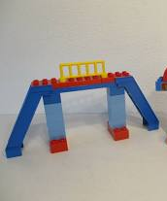 | CHILD INITIATED LEARNING  The children can choose their own toy/learning activity  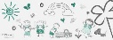  Microsoft Teams  Literacy Review of Learning  2-2:15 Red group  2:15-2:30 Blue group | Story Time  Pick your favourite story or read your school books
Wednesday | Microsoft Teams  Morning Welcome  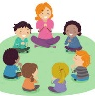 | Phonics  Link:  https://www.youtube.com/watch?v=DgD6yCIO3pw  Lesson: 44 part 1 | Maths  Oak Academy  Link: https://classroom.thenational.academy/lessons/using-manipulatives-to-count-on-when-adding-60vpat  Lesson: Addition and subtraction within 10  Lesson 1:  Using manipulatives to count on when adding |  | Maths  Mathletics activity  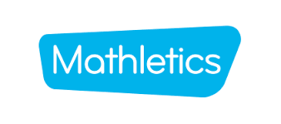 |  | PSHE  Oak Academy  Link:  https://classroom.thenational.academy/lessons/glitter-germs-c9j3at  Lesson: A new Normal lesson 3  Glitter germs | CHILD INITIATED LEARNING  The children can choose their own toy/learning activity  Microsoft Teams  Maths Review of Learning  2-2:15 Red group  2:15-2:30 Blue group | Story Time  Pick your favourite story or read your school books
Thursday | Microsoft Teams  Morning Welcome  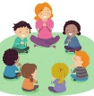 | Phonics  Link: https://www.youtube.com/watch?v=eN6GmiiR_2s  Lesson: 44 part 2 | Literacy  Oak Academy  Link:  https://classroom.thenational.academy/lessons/to-recycle-the-story-of-the-three-billy-goats-gruff-6xjk6t  Lesson: The Three Billy Goats Gruff: Lesson 6:  To recycle the story of The Three Billy Goats Gruff |  | Reading  Phonics Game (2do) |  | Computing  Purple Mash  2 race addition to 5 (2do) | CHILD INITIATED LEARNING  The children can choose their own toy/learning activity  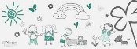 | Story Time  Pick your favourite story or read your school books
Friday | Microsoft Teams  Morning Welcome  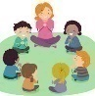 | Phonics  Link:  https://www.youtube.com/watch?v=JadqW0SsDi4&list=PLuGr6z2H2KNHwnu179dNafu7_mj4Nvjgp&index=8  Lesson: 8 | Maths  Oak Academy  Link:  https://classroom.thenational.academy/lessons/adding-two-numbers-using-a-number-track-to-count-on-cmvk0t  Lesson: Addition and subtraction within 10  Lesson 2:  Adding two numbers using a number track to count on. |  | Maths  Mathletics activity |  | Music  Oak Academy  Link: https://classroom.thenational.academy/lessons/me-and-my-family-part-1-c5h3et  All about Me  Lesson 3: Me and my family (Part 1) | GOLDEN TIME  Activity of choice | Story Time  Pick your favourite story or read your school books

