Learning Objectives for the week:
Reading:
The children will be able to retell the story of ‘The Little Red Hen’.
To learn how to plan a new story.

Phonics:
The children will recognise the letters ar, or and read words with these sounds.
The children will be able to read their word set.
The children will be able to recognise the tricky word you.
The children will be able to spell the tricky words: the, to, I, no, go, was, he, she, we, me, be, all and are.

Writing:
To learn how to write a speech bubble.
The children will be able to write simple sentence for a picture.
The children will be able to write their first name and surname in cursive letters.(Please encourage your child to write their name daily)

Maths:
To learn to find half of a number.
To explore doubling and halving.
 | Registration  9:10-9:20  Microsoft Teams all children to attend registration | 9:20-9:40 | 9:40-10:30 | Brain Break https://www.bbc.co.uk/teach/supermovers/ks1-collection/zbr4scw | 11:00--12:00 | Lunchtime 12:00-1:20 | 1:20-2:00  Review of learning  Class Teacher to call groups of children on Microsoft Teams. | 2:00-2:45  Review of learning  Class Teacher to call groups of children on Microsoft Teams. | 2:45-3:00
Monday | Microsoft Teams  Morning Welcome  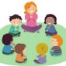 | Phonics  Link: https://www.youtube.com/watch?v=IUHj1V-KYeg  Lesson: 18 (ar) | Reading  Phonics Play  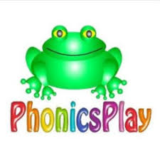  Link: https://www.phonicsplay.co.uk/resources/phase/2/dragons-den  Dragons Den (Phase 3 ar)  Can you read the sentence and draw a picture:  The man is on the moon.  I can see the big red book. |  | Reading  Bug club : Read Books and word sets  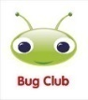 |  | Understanding The World  Oak Academy  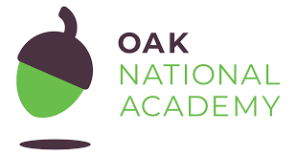  Link: https://classroom.thenational.academy/lessons/to-sequence-the-life-cycle-of-an-animal-6hk38c  Lesson: On the Farm. Growing (Animals)  To sequence the life cycle of an animal  Microsoft Teams  Reading Review of Learning- Word sets (Individually)  1:20- 2:00 Yellow group  2:00- 2:40 Green group | CHILD INITIATED LEARNING  The children can choose their own toy/learning activity | Story Time  Pick your favourite story or read your school books  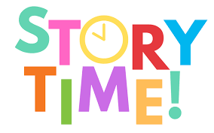
Tuesday | Microsoft Teams  Morning Welcome  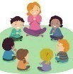 | Phonics  Link: https://www.youtube.com/watch?v=HbRKL68I1WQ  Lesson: 19 (or) | Literacy  Oak Academy  https://classroom.thenational.academy/lessons/to-tell-the-story-independently-focusing-on-character-crtpac  Lesson: Little Red Hen  Lesson 5:  To tell the story independently, focusing on character. |  | Writing  Can you write a simple sentence for the picture?  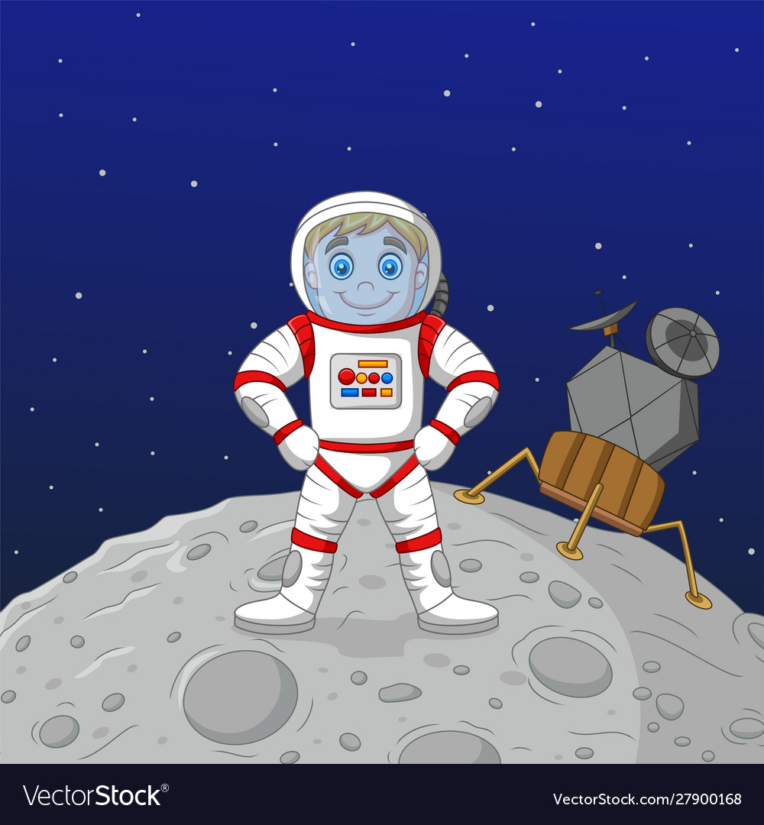  e.g.  A man is on the moon.  Can you write your tricky words?  the, to, I, no, go, was, he, she, we, me, be, all, are. |  | D and T  Can you make your own Little Red Hen? Here is an example.  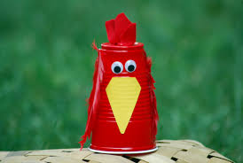 | CHILD INITIATED LEARNING  The children can choose their own toy/learning activity  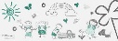  Microsoft Teams  Literacy Review of Learning  Show & Tell  2-2:15 Yellow group  2:15-2:30 Green group | Story Time  Pick your favourite story or read your school books
Wednesday | Microsoft Teams  Morning Welcome  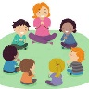 | Phonics: Recap the ‘or’ digraph and play a game to practise your reading.  Phonics Play  Link: https://www.ictgames.com/phonicsPop/index.html  Picnic on Pluto (Phase 3 or) | Maths  Oak Academy  Link: https://classroom.thenational.academy/lessons/understanding-the-concept-of-half-part-1-ccvp8t  Lesson: Doubling and halving.  Lesson 2:  Understanding the concept of half (Part 1) |  | Maths  Mathletics activity  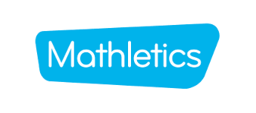 |  | PSHE  Oak Academy  Link:  https://classroom.thenational.academy/lessons/squeaky-clean-68r3ct  Lesson: Squeaky clean: lesson 1  Squeaky clean | CHILD INITIATED LEARNING  The children can choose their own toy/learning activity  Microsoft Teams  Maths Review of Learning  2-2:15 Yellow group  2:15-2:30 Green group | Story Time  Pick your favourite story or read your school books
Thursday | Microsoft Teams  Morning Welcome  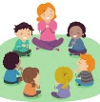 | Phonics  Link:  https://www.youtube.com/watch?v=bTGhuqCepYQ  Lesson: 20 Review of sounds | Literacy  Oak Academy  Link:  https://classroom.thenational.academy/lessons/to-recycle-the-story-of-the-little-red-hen-and-change-the-ending-6tk3ae  Lesson: Little Red Hen:  Lesson 6:  To recycle the story of The Little Red Hen and change the ending. |  | Reading  Phonics Game (2do) |  | Computing  Purple Mash  Farm (2do) | CHILD INITIATED LEARNING  The children can choose their own toy/learning activity | Story Time  Pick your favourite story or read your school books
Friday- | Microsoft Teams  Morning Welcome  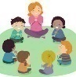 | Phonics: Recap the digraph we have learned so far and play a game to practise your reading.  Please use your login which has been sent through Purple Mash  Link: https://app.discoveryeducation.co.uk/learn/signin  Activity: Blending (oo short, oo long, ar, or) | Maths  Oak Academy  Link:  https://classroom.thenational.academy/lessons/understanding-the-concept-of-half-part-2-64v30e  Lesson: Doubling and halving.  Lesson 3:  Understanding the concept of half (Part 2) |  | Maths  Mathletics activity |  | Music  Oak Academy  Link: https://classroom.thenational.academy/lessons/me-and-my-friends-part-2-71jk0t  All about Me  Lesson 6: Me and my friends (Part 2) | GOLDEN TIME  Activity of choice | Story Time  Pick your favourite story or read your school books

