Learning Objectives for the week:

Reading:
The children will be able read books matched to their colour book band (Bug Club)
The children will be able to answer questions about the book they have read (Bug Club)
The children will be able to talk about the story (Oak academy)
The children will be able to read words (sight vocabulary words sent via Purple Mash).

Phonics:
The children will be able to blend words to read matched to their phonic ability e.g. royal and playful (practise reading words sent via Purple Mash)

Writing:
To gather information from an information texts
To identify the features of an information text

Maths:
The children will be able to order number 1-20 on a number line.
To identify one more and one less of numbers to 20.
The children will be able to compare numbers to 20.

 | 9:00-9:20 | 9:30-10:30 | PE/Brain Break Super Movers | 11:00--12:00 | Lunchtime 12:00-1:00 | 1:00-1:45 | 2:00-2.45 | 2.45 – 3.00
Monday | Microsoft Teams  Morning Welcome  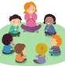 | Jigsaw  PSHE – National Academy Year 1 PSHE  Link: https://classroom.thenational.academy/lessons/my-lockdown-feelings-6mw66c  Topic: Lockdown Capsule  Lesson: 3 My lockdown feelings. |  | Literacy – Bug club  Link:  Reading comprehension – answer questions about the books you are reading.  Complete activity.  11.40 – 12.00  Phonics  Flashcards  https://app.discoveryeducation.co.uk/learn/videos/4739d56f-fe0c-48c7-8026-5a28f17056c5/  Espresso  Activity  ‘wh’ spelling activity espresso |  | PE  Cosmic yoga.  Link:  https://www.youtube.com/watch?v=LhYtcadR9nw | Music – National Academy Year 1 Music  Link: https://classroom.thenational.academy/lessons/rhythms-6rtp6c  Topic: rhythm and pulse lesson 2. | Story Time with your child
Tuesday | Microsoft Teams  Morning Welcome | Maths National Academy Year 1 Maths –  Link:  Link:To position numbers to 20 on a number line (thenational.academy)  Topic: Numbers to 20  Lesson 3- To position numbers to 20 on a numberline.  Activity- Purple mash- Missing numbers |  | Literacy – National Academy Year 1 English  Topic: Information texts-  Lesson: - 5  Activity- Retrieving information.  Link: https://classroom.thenational.academy/lessons/to-retrieve-information-61jk4t  Phonics  Flashcards  https://app.discoveryeducation.co.uk/learn/videos/3e1bb148-39a5-4eab-a518-20a8c54e41e8/  Espresso  Activity  https://www.phonicsplay.co.uk/resources/phase/2/buried-treasure  Phase 5 ‘ph’ sound |  | D and T  Can you design and make an animal home for an animal of your choice?  For example:  Tree  Ocean  Jungle  Arctic.  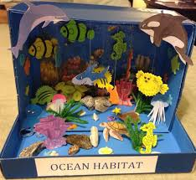  I’ve used an old shoe box! | Computing  Link: https://www.purplemash.com/#app/tools/2type0_AllkeysAZ  On purple mash complete the two computing activities! | Story Time with your child
Wednesday | Microsoft Teams  Morning Welcome | Maths National Academy Year 1 Maths –  Link: To identify one more and one less than a number within 20 (thenational.academy)  Topic: Numbers to 20  Lesson 4: To identify 1 more and 1 less  Activity- Purple mash-  One more and one less |  | Literacy – National Academy Year 1 English  Topic:  Lesson: 7  Activity- identifying features of an information text  Link: https://classroom.thenational.academy/lessons/to-identify-features-of-an-information-text-read-as-a-writer-74u6ae  Phonics  11.40 – 12.00  Flashcards  https://app.discoveryeducation.co.uk/learn/videos/455dd94f-3f6c-4f6b-b98d-984e270230b9/  Espresso  Activity  https://www.phonicsplay.co.uk/resources/phase/2/picnic-on-pluto  Obb and Bob phase 5 ‘au’ sound |  | Art  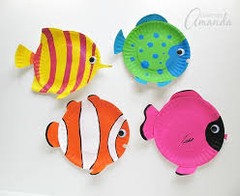  Create your own fish using a paper plate and a range of different colours.  Link: https://www.easypeasyandfun.com/paper-plate-fish-craft/ |  | Story Time with your child
Thursday | Microsoft Teams  Morning Welcome | Maths National Academy Year 1 Maths –  Link:To compare numbers to 20 (thenational.academy)  Topic: Numbers to 20  Lesson 5: To compare numbers to 20  Activity- Purple Mash  Place Value tens and ones |  | Literacy – National Academy Year 1 English  Topic: World book day  Activity:  Draw a picture of your favourite story character.  Write me a sentence starting  My favourite character is…  Because…  Phonics  11.40 – 12.00  Flashcards  https://app.discoveryeducation.co.uk/learn/videos/455dd94f-3f6c-4f6b-b98d-984e270230b9/  Espresso  Activity  https://www.phonicsplay.co.uk/resources/phase/2/dragons-den  Dragons den phase 5 ‘aw’ sound. |  | WORLD BOOK DAY  Link: https://www.worldbookday.com/2020/09/world-book-day-2021-announcements/  Can you create a puppet of a character from your story?  https://www.diys.com/puppets-your-kids-will-love/ | WORLD BOOK DAY  Lesson: Design and create your own book mark!  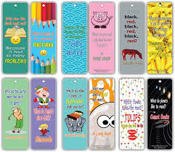 | Story Time with your child
Friday | Microsoft Teams  Morning Welcome | Science –  Topic: Sugar Crystals experiment.  I will send the experiment details via purple mash. |  | Maths National Academy Year 1 Maths –  Link: To compare and order three numbers within 20 (thenational.academy)  Topic: Numbers to 20  Lesson: 6- To compare and order 3 numbers  Activity- Place Value 10’s and ones  Phonics  11.40 – 12.00  Practice new word sets from home. |  | History –  Topic: Florence Nightingale  Lesson: Draw a portrait of Florence Nightingale  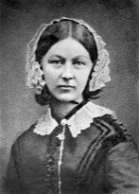 | Golden Time  You have worked hard all week so you can choose your favourite activity for golden time. | Story Time with your child

